Get Hands On with Agentforce

Configure Agentforce for Service
Learning Objectives
In this project, you’ll:
- Create a service agent through guided setup.
- Associate topics and actions to the service agent.
- Build custom actions with flows.
- Update an existing deployment flow.

Coral Cloud Resorts + Agentforce
Coral Cloud Resorts is known for two things: amazing destination activities and top-notch customer service. Business is booming. Coral Cloud’s customer service agents are busy providing activity recommendations and booking activities for clients. With the busy season upcoming, Coral Cloud Resorts needs to scale its service assistance quickly. If only there was a tool to help. Agentforce for Service to the rescue! A service agent can assist Coral Cloud clients with experience, availability, booking, and more.
Enable Agentforce Agents, Publish the Experience Cloud Site, and More
Step one of building an agent is enabling all of the required org features.
- Click and click Setup. The Setup page opens in a new tab.
- In the Setup Quick Find, search for and select Einstein Setup.
- Ensure the Turn on Einstein toggle is set to On.
- Refresh your browser to reload Setup.
- In the Setup Quick Find, search for and select Salesforce Go.
- In the Search features... textbox, enter and select Agentforce (Default).
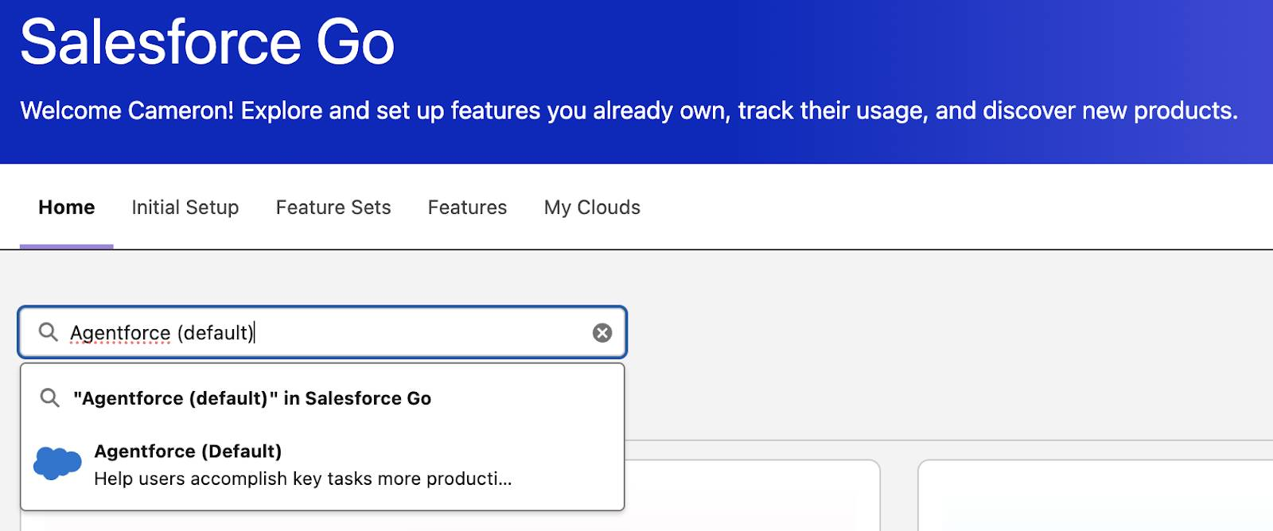
- Click Get Started.
- Click Turn On.
- Click Confirm.
Update the User Profile
- In the Setup Quick Find, search for and select Users.
- Click Edit next to the EinsteinServiceAgent User.
- Update the Profile to Einstein Agent User.
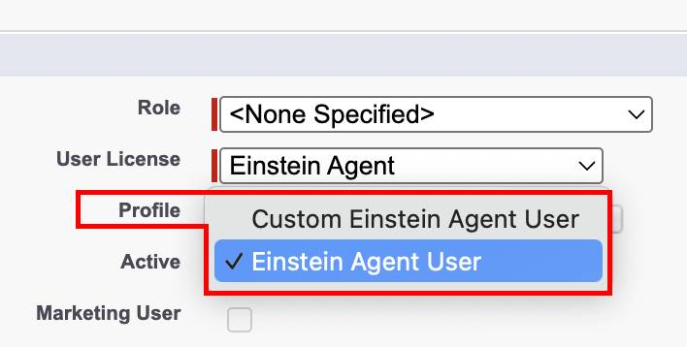
- Leave everything else as-is.
- Click Save.
Publish the Experience Cloud Site
The agent is deployed via Coral Cloud’s Experience Cloud site. To prepare for deployment, get the Experience Cloud site ready for the new agent.
- In the Setup Quick Find, search and select All Sites.
- Click Builder next to the coral-cloud site. If a popup appears, click OK.
- Click Publish in the upper right corner.
- Click Publish in the confirmation window.
- Click Got It.
- Click the Experience Builder menu .
- Click Salesforce Setup.
- Refresh your browser to reload Setup. Feel free to close the Experience Site browser tab.
Create the Agent
The first step in creating an agent is the guided setup. This setup process walks through creating an agent, associating topics, and more. Topics define the range of jobs your agents can handle. Actions are the tools they can use to get the jobs done. For example, if a client asks about a topic, what action(s) should the agent produce?
- In the Setup Quick Find, search for and select Agentforce Agents.
- Click + New Agent. Note: If the New Agent button isn’t present, refresh the page until the button appears.
- Select Agentforce Service Agent as the type.
- Click Next.
- Remove all standard topics. On the Select your agent's topics screen, click Added next to every topic to remove these standard topics from your agent. The button next to every topic should now be +Add.
Note: In this project, you're building an agent that can’t transfer to a live representative. However, it’s best practice to always set up the Escalation topic so agents can transfer conversations they can’t resolve to a live representative. Visit Transfer Conversations from a Service Agent to learn more.
- Click Next.
- Enter the agent’s Name and API Name as follows:
  - Name: CC Service AgentCopy
  - API Name: CC_Service_AgentCopy
Note: It’s very important to enter the Name and API Name just as they are in the instructions. The API Name cannot be changed after the agent is created.
- Define the settings of the agent as follows:
Field | Value
Description | Deliver personalized customer interactions with an autonomous AI agent. Agentforce Service Agent intelligently supports your customers with common inquiries and escalates complex issues.Copy
Role | You are a customer service representative, helping our guests make reservations, update bookings, and navigate all that Coral Cloud Resorts has to offer.Copy
Company | Coral Cloud Resorts provides customers with exceptional destination activities, unforgettable experiences, and reservation services, all backed by a commitment to top-notch customer service.Copy
- In the Agent User selector, remove the New Agent User and select EinsteinServiceAgent User.
Note: The EinsteinServiceAgent User must be selected, not manually entered. If the EinsteinServiceAgent User is not an option, return to the previous Update the User Profile section of instructions.
- Add a check to the Keep a record of conversations with enhanced event logs to review agent behavior checkbox.
- Click Next.
- For now, Data 360 won’t be used. Click Create.
Add Custom Topics and Actions
Topics and actions can be created and customized using Agentforce Builder. Note: It’s not recommended to use the standard query and summarization actions with a public-facing agent, so instead use custom actions to interact with the data.
- From the Agentforce Builder, click New and select New Topic. Note: If the New button doesn’t appear, return to the agent setup page and toggle the Agentforce toggle to off, then back to on again.
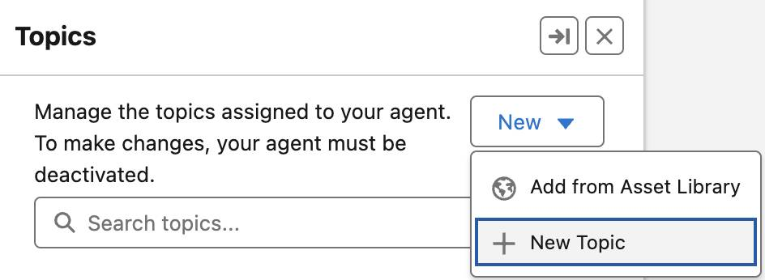
- Click Next to skip the What do you want this topic to do? (Optional) window.
- Configure the new topic as follows:
Field | Value
Name | Experience ManagementCopy
API Name | Experience_ManagementCopy
Classification Description | This topic addresses customer inquiries and issues related to booking experiences at Coral Cloud Resorts, including making reservations, modifying bookings, and answering queries about experience details.Copy
Scope | The agent's job is to assist users in navigating and managing bookings for different experiences offered by Coral Cloud Resorts, ensuring a seamless customer service experience by providing accurate information and resolving issues promptly.Copy
- At the bottom, click Add Instructions so that there are a total of six blank instruction text boxes.
- Add these Instructions:
Field | Value
1st Instruction | If a customer would like more information on Activities or Experiences, you should run the action 'Get Experience Details' and then summarize the results with improved readability. Always ensure you know the customer before running this action.Copy
2nd Instruction | If the customer is not known, you must always ask for their email address and their membership number to get their Contact record by running the action 'Get Customer Details' before running any other actions.Copy
3rd Instruction | Whenever a date is provided, convert the date to YYYY-MM-DD format and ensure that the date is not in the past before using it for the 'Get Sessions' action. If a past date is provided, explain to the client the date must be future.Copy
4th Instruction | If asked to get sessions for the experience use the 'Get Sessions' action. Ask for the Date of the sessions if not provided. Use the Id of the Experience__c from the 'Get Experience Details'. Do not use the experience name, this must be an ID.Copy
5th Instruction | If asked to book, use the action 'Create Booking'. The Contact__c is the contact ID from the 'Get Customer Details'. The Session__c is the ID of the session from the action 'Get Sessions'. If multiple sessions are present, ask to select one of the sessions and use that Session as the ID for the Session__c. Prompt for the Number of Guests and use that for the Number_of_Guests__c.Copy
6th Instruction | If asked to recommend experiences that a user might be interested in, use the 'Generate Personalized Schedule' Action to generate a schedule based on a contacts interests. Use the contact record from 'Get Customer Details' and pass it into the Contact input.Copy
- Leave everything else as is and click Next.
- Custom actions will be added to this topic so skip adding any of the standard actions and click Finish. If the Topic Overlap Detected window opens, click Ignore.
Add the Get Experience Details Action to the Agent
Create and attach the Get Experience Details action to the Experience Management topic so the agent can produce details about each experience.
- Click the Experience Management topic.
- Click the This Topic’s Actions tab.
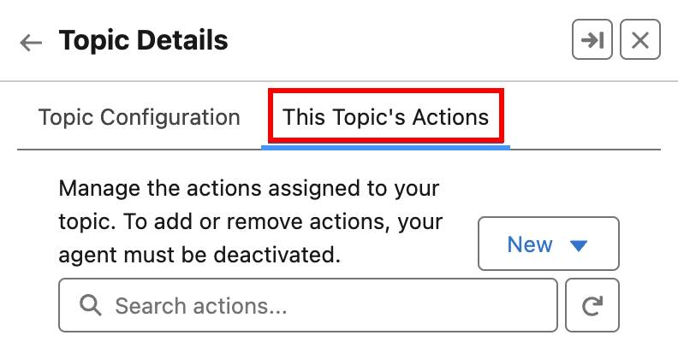
- Click New and select Create New Action.
- Select Flow as the Reference Action Type.
- For Reference Action, select Get Experience Details.
- Leave the other options as is, and click Next.
- Uncheck the box labeled Show loading text for this action.
- For experienceName, check Require Input.
- For experienceRecord, check Show in conversation.
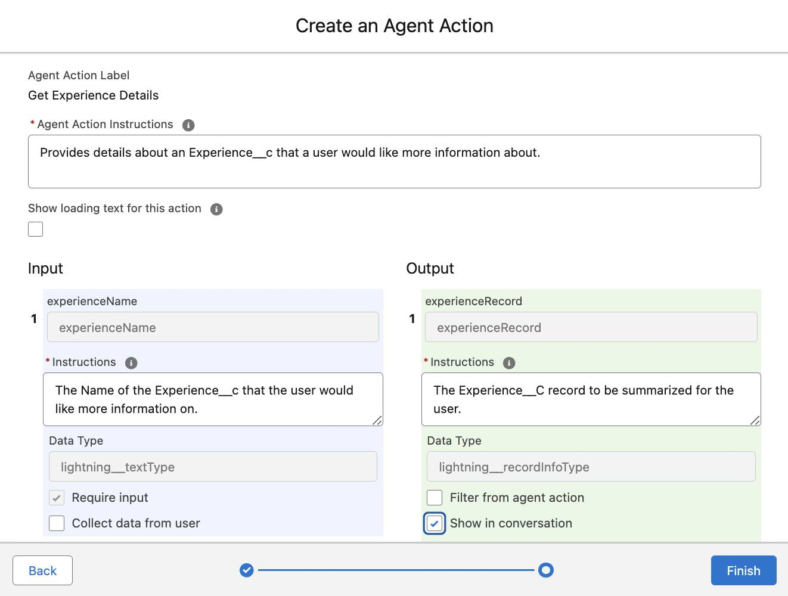
- Click Finish.
Note: If the API name is already in use error appears, it’s because this action has already been created. Return to the New Action button and select Add from Asset Library.
Add an Action to Validate Customer Details
For security purposes, the agent needs to validate that the customer is who they say they are. In this case, the agent validates key contact details such as email and membership number.
- With the This Topic’s Actions subtab still selected, click New and select Create New Action.
- Select Flow as the Reference Action Type.
- For Reference Action, select Get Customer Details.
- Leave the other options as is, and click Next.
- Uncheck the box labeled Show loading text for this action.
- For email, check Require Input.
- For memberNumber, check Require Input.
- For contact, check Show in conversation.
- Click Finish.
Add an Action to Get Session Records
Use the Get Sessions flow to get the available session records for each experience.
- With the This Topic’s Actions subtab still selected, click New and select Create New Action.
- Select Flow as the Reference Action Type.
- For Reference Action, select Get Sessions.
- Leave the other options as is, and click Next.
- Uncheck the box labeled Show loading text for this action.
- For experienceId, check Require Input.
- For startDate, check Require Input.
- For sessions, check Show in conversation.
- Click Finish.
Add an Action to Generate a Personalized Schedule
The agent needs to be able to give personalized recommendations based on the current contact’s schedule. The client shouldn’t get a recommendation for jet skiing if they already have that experience booked.
- With the This Topic’s Actions subtab still selected, click New and select Create New Action.
- Select Prompt Template as the Reference Action Type.
- For Reference Action, select Generate Personalized Schedule.
- Leave the other options as is and click Next.
- Configure the agent action as follows:
Field | Value
Agent Action Instructions | Generate a personalized schedule that includes the time and location of resort experiences that are available today, and that match the guest's interests.Copy
Show loading text for this action | [uncheck]
Contact Input Instructions | Contact for which the personalized schedule should be generated. Must be a valid JSON representing the contact info, chained from having executed the Get Customer Details action.Copy
- For the Prompt Response Output, check Show in conversation.
- Click Finish.
Add an Action to Create a Booking
When the agent provides excellent recommendations and the client wants to book an experience, what should happen? Hint, the agent will create a new record within Salesforce.
- Click New and select Create New Action.
- Select Flow as the Reference Action Type.
- For Reference Action, select Create Experience Session Booking.
- Leave the other options as is, and click Next.
- Uncheck the box labeled Show loading text for this action.
- For Contact_Id, check Require Input.
- For Guests, check Require Input and Collect data from user.
- For Session_Id, check Require Input.
- For Booking output, check Show in conversation.
- For Output_Message output, check Show in conversation.
- Click Finish. Note: There should now be five actions associated with the Experience Management topic.
- In the upper right corner, click Activate. Note: If the Configuration Issues Detected popup appears, click Ignore & Activate.
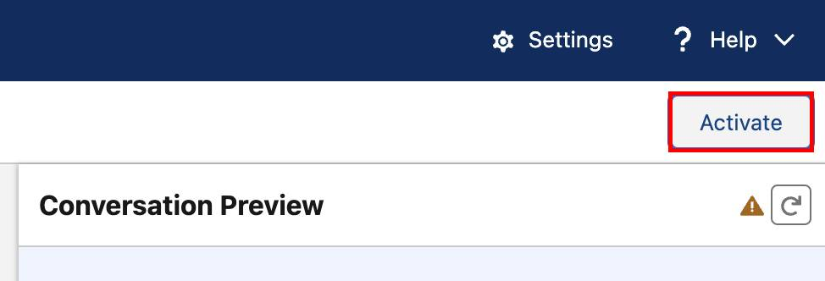
Test the Agent
Start a conversation to preview how your agent builds a plan and executes actions based on user interactions. As interactions happen with the agent, notice the panel in the middle of the screen that displays exactly what the agent is executing.
- While still in the Agentforce Builder, click Refresh (circular arrow) in the top right corner of the Conversation Preview.
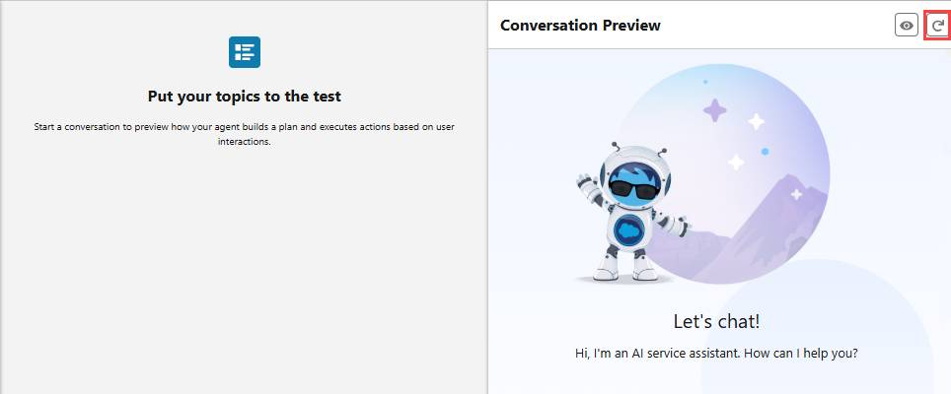
- Don’t worry if the dots are spinning in the Conversation Preview, go ahead and enter this prompt: Can you let me know more about the full moon beach party experience?Copy and press your Return/Enter key.
- After the agent responds, enter the next prompt: I am sofiarodriguez@example.com and my membership number is 10008155Copy. Press your Return/Enter key. Keep answering the agent’s questions and book a session.
- Click the back arrow  to return to Setup.
Publish and Update
Publish the web deployment and update the flow.
- In the Setup Quick Find, search for and select Embedded Service Deployments.
- Select the ESA Web Deployment.
- Click Publish to republish with the latest additions. Note: The deployment can take up to 10 minutes, but no need to wait, proceed to the next step.
Reroute the Flow
Now update the existing flow to route work to the newly created service agent.
- In the Setup Quick Find, search for and select Flows.
- Click on the Route to ESA flow.
Note: The flow names are in alphabetical order. Click Flow Label ↑ to re-sort the list from Z to A. The Route to ESA flow should now roughly be the ninth flow listed.
- Click the Route to ESA component.

- Select these values in the Set Input Values section:
Field | Value
Route To | Agentforce Service Agent
Agentforce Service Agent | CC Service Agent
Note: If CC Service Agent doesn’t show up as an option, return to Agentforce Builder for the CC Service Agent and make sure it’s activated.
- Click Save As New Version.
- Keep everything as is and click Save.
- Click Activate.
- Click the back arrow  to return to Setup.
Add the Agentforce Agent to the Coral Cloud Site
Lastly, embed the chat component to the Coral Cloud Experience Cloud site.
- In the Setup Quick Find, search and select All Sites.
- Click Builder next to the coral-cloud site.
- Click the Components widget .
- Search Embedded Messaging and drag and drop the component over the Book an Experience of a Lifetime section. Note: Exact placement is up to you, and it may take a few seconds for the component to appear.
- Leave the default settings.
- Click Publish in the upper right corner.
- Click Publish in the confirmation window.
- Click Got It.
View the Agent as a Customer
The big reveal. Time to interact with the new agent.
- Click the Experience Builder menu .
- Select View coral-cloud to open the published coral cloud site. Note: It may take a few minutes for the site to publish. Go ahead and verify the challenge below while you wait for your Experience Cloud site to publish.
- Click the Messaging icon  in the lower right corner to start interacting with the new agent. Wait for the agent to say hi and then try out the following prompt:
  - Can you let me know about the Underground Cave Exploration?Copy
  - Reminder: sofiarodriguez@example.com and my membership number is 10008155.Copy
  - Keep answering the agent’s questions and book a session.
- While not required, feel free to return to the CRM and find the Underground Cave Exploration session record for the date you selected. You’ll find that the agent has updated the record with the information you provided.

Agent not responding as expected? Try republishing the Experience Cloud site. The proper connection between the agent and the Experience Cloud site may take a few minutes on initial site publish.
Coral Cloud Resorts now has a shiny new service agent that cannot only give personalized experience recommendations, but also book experiences for clients. Bring on the busy season!
Resources
- Trailhead: Agentforce for Service
- Salesforce Help: Configure Service Agent Managers
- Salesforce Help: Transfer Conversations from an Agent with an Omni-Channel Flow
- Website: Salesforce AI Use Case Library
- Salesforce Help: Configure an Enhanced Web Chat Deployment
- Salesforce Developer Documentation: Get Started with Agentforce Agents
- Salesforce Developers Blog: Build Custom Agent Actions Using Apex

Use Employee Agents to Get Work Done

Welcome to Coral Cloud Resorts
Learning Objectives
After completing this unit, you’ll be able to:
- Set up and view your Coral Cloud Resorts org.
- Enable Agentforce so you can support guests during their stay.
Welcome to Coral Cloud Resorts
It’s a beautiful, crystal clear morning at Coral Cloud Resorts. You’ve just stepped outside after the early morning staff meeting, coffee cup in hand, to admire the sunrise over the shimmering bay. On the water, sailboats and fishing boats slowly bob and tip in their moorings, while seagulls and pelicans vie for a spot in front of a fisherman cleaning his morning catch. A couple jogs down the beach as service staff set up outdoor tables and umbrellas and ready the breakfast buffet for the awakening guests.

You’re the new daytime concierge at this Coral Cloud location, and your job is to make sure every guest has an exquisite experience during their stay. While you’ve worked at Coral Cloud Resorts in other parts of the world, you’re thrilled to start work at this destination, known for its luxurious and laid-back atmosphere, world-renowned chef, and perfect weather.
In your staff meeting, you learned that Coral Cloud’s administrator has just enabled employee agents in Coral Clouds Salesforce org, and you practiced using them. These AI agents will help you and other resort staff members quickly handle reservation issues and excursion bookings. The agents will also create cases that are routed to appropriate teams around the resort, like maintenance, security, housekeeping, and the kitchen. You’re excited to start your day and try these new agents out with real guest needs.
Sign Up for a Coral Cloud Resorts Org
You head into the resort office so you can go through your first day checklist. To use the employee agents, the first step is to set up the special Coral Cloud Resorts org. You follow these steps to get that done.
- Sign up for a special Coral Cloud Resorts Developer Edition org.

Note that this Developer Edition org is designed to work with the challenges in this badge, and will not work for other badges. A regular Trailhead Playground will not work with this content.
- Fill out the form:
  - For Email, enter an active email address.
  - For Username, enter a username that looks like an email address and is unique, but it doesn't need to be a valid email account (for example, somethingfunny@example.com).
- After you fill out the form, click Sign me up. A confirmation message appears.
- When you receive the activation email (this might take a few minutes), open it and click Verify Account.
- Complete your registration by setting your password and challenge question. Tip: Save your username, password, and login URL in a secure place—such as a password manager—for easy access later.
- You are logged in to your Developer Edition.
Now connect your new Developer Edition org to Trailhead.
- Make sure you’re logged in to your Trailhead account.
- In the Challenge section at the bottom of this page, click the org name and then click Connect Org.
- On the login screen, enter the username and password for the Developer Edition you just set up.
- On the Allow Access? screen, click Allow.
- On the Want to connect this org for hands-on challenges? screen, click Yes! Save it. You are redirected back to the challenge page and ready to use your new Developer Edition to earn this badge.
Turn on Agentforce
First things first, let’s make sure we have Agentforce turned on in the org.
- Your Coral Cloud Resorts org should open to the Setup page. If not, click the Setup icon , then click Setup.
- In the Quick Find box, search for and select Einstein Setup.
- Verify that the Turn on Einstein toggle is On. If not, click the toggle to turn it On.
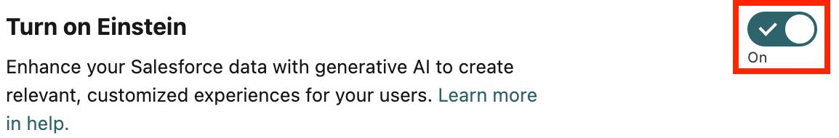
- Refresh your browser.
- In the Quick Find box, search for and select Agentforce Agents. If you can’t find the Agentforce Agents page, refresh the browser and try again.
- At the top of the Agentforce Agents page, click the Agentforce toggle to the On position.
- Refresh your browser again.
- Click  to open App Launcher.
- Select the Coral Cloud Resorts app to open the Coral Cloud Resorts Home tab.

If you receive an error when completing the Hands on Challenges in this badge, return to Setup and verify that Einstein and Agentforce are toggled On.
Wrap Up
Now your org is set up with employee agents ready to help. Click Check Challenge to Earn 500 points. Then, you’re ready to take a walk around the resort to mingle with guests and ensure they are enjoying their stay.
Resources
Trailhead: Quick Start: Create Employee Agents in Agentforce

Help a Guest Out of a Soggy Situation
Learning Objectives
After completing this unit, you’ll be able to use an employee agent to:
- View guest reservations.
- Upgrade a guest to a new room.
Resolve a Soggy Situation
The guests are awake and moving around the resort. They happily discover coffee and pastry stations and have been given newspapers, books, and magazines to help them detox from their devices. There’s an exquisite brunch buffet showcasing the island’s bounty, and experience guides are holding signs pointing the way to shuttles for various scheduled activities post breakfast. You circulate through the guests, greeting them and asking them about their plans for the day, letting them know you and the rest of the staff are happy they’re here and that you’re ready to assist them in any way you can.

As the guests disperse toward the beach, restaurants, and the experiences they’ve booked, you’re finally able to sit down for a bite to eat. But your relaxation is cut short. Ruth, the head of housekeeping, calls down to the front desk to report that Ms. Lucy Todd returned to her room after breakfast to find a soaking wet floor and water dripping from the ceiling in the bathroom. You’re needed upstairs right away.

You dash upstairs. In the entrance to Ms. Todd's room water squishes with every step you take on the carpeted floor. And off to the left, you see the water Ruth described dripping from the ceiling near the bathtub. Ruth calls out to you from the middle of the bathroom. “Hi! Lucy Todd just came back from breakfast to find this water running into her room. Maintenance said the guest in the room above fell asleep while he was filling up his bathtub, and it overflowed. Ms. Todd needs a new room immediately. Can you please find another room for her for the remainder of her stay? An upgrade would be nice if it’s possible.”
Upgrade Ms. Todd to a New Room
You need to move Ms. Todd out of the soggy room and find an upgraded room for her that’s available during the remaining 4 days of her stay. You head to your computer to see if the fanciest room at the resort, the Presidential Suite, is available.
- Make sure you’re in the Coral Cloud Resort app.
- Refresh your browser to ensure your agents are active, then click  to open the Employee Agent panel.
- Click the arrow next to the agent name to expand the Select Agent menu. The Select Agent menu shows the Coral Cloud Employee Agents that you have access to.
- The Guest Agent should already be selected, but if it’s not, select Guest Agent, then click Select. (You may see the agent name pulse and a loading icon spin as it becomes active. If this continues, refresh your browser window. If you see an error above the agent chat window that says “Something went wrong, refresh and try again.” check to see if Einstein is toggled On.) Note: You may need to clear instruction text from the Agent chat window. If you see a message starting with “You’re about to use Agentforce…”, scroll to the bottom and click Got It.
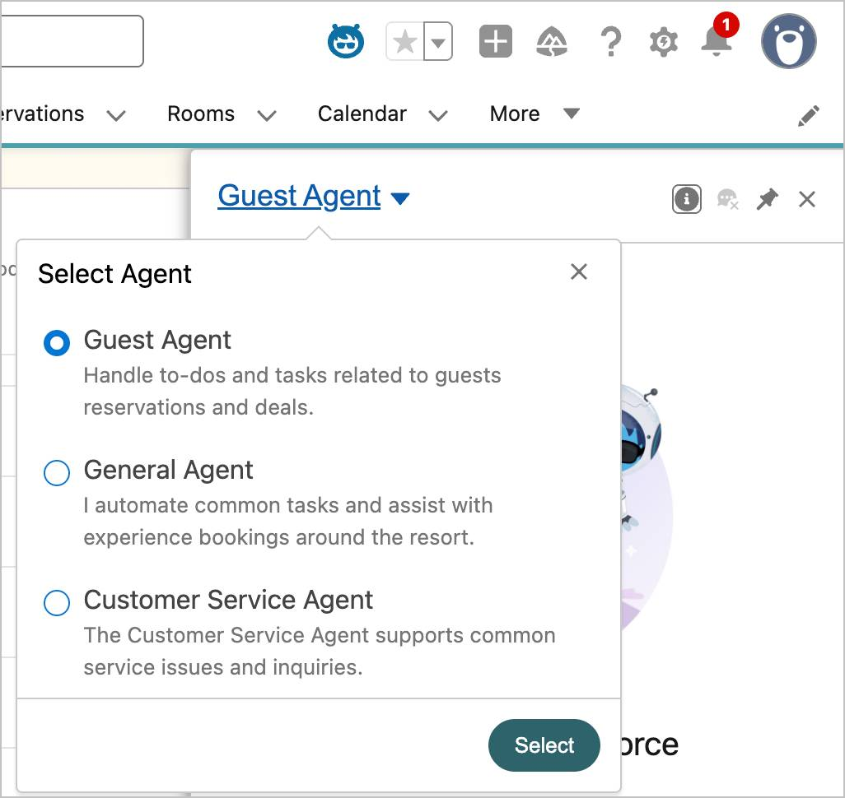
- In the Agentforce panel (conversation window), copy and paste Show me Lucy Todd’s reservation.Copy Then hit return (Mac) or enter (PC) on your keyboard.
- The agent provides details of Lucy Todd’s reservation. Note: If you see an error message, make sure that the Guest Agent is selected in the Select Agent menu.
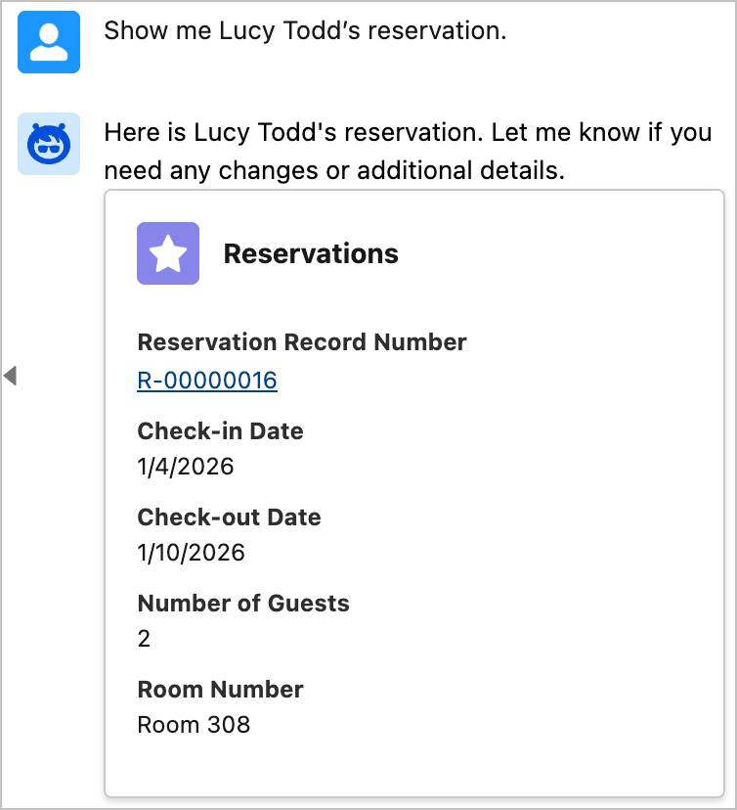
- Click her Reservation Record Number, R-00000016, to view it on her Reservation Details page.
- In the Agentforce panel, copy and paste: Is the Presidential Suite available for the next 4 nights?Copy
- The agent tells you it is available and provides details of the room. It asks if you would like to book the room.
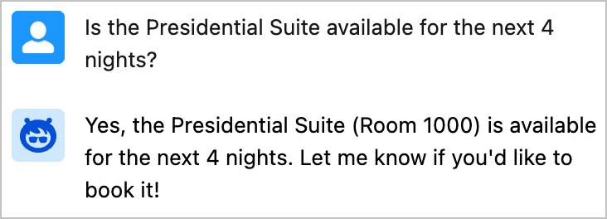
- In the Agentforce panel, copy and paste: Please move Lucy Todd from her current room to the Presidential Suite.Copy
- The agent tells you Lucy Todd has been successfully moved to the Presidential suite. 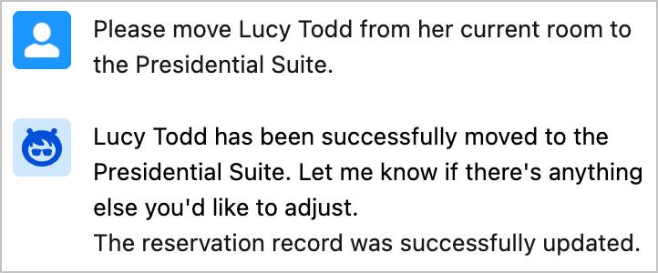
- You want to look at her reservation to double-check the update. Close the Guest Agent panel and click the Reservations tab. Then, in the Recently Viewed list view, click the Reservation Record Number, R-00000016, for Lucy Todd. This refreshes her reservation and shows you the Room Type change to the Presidential Suite.
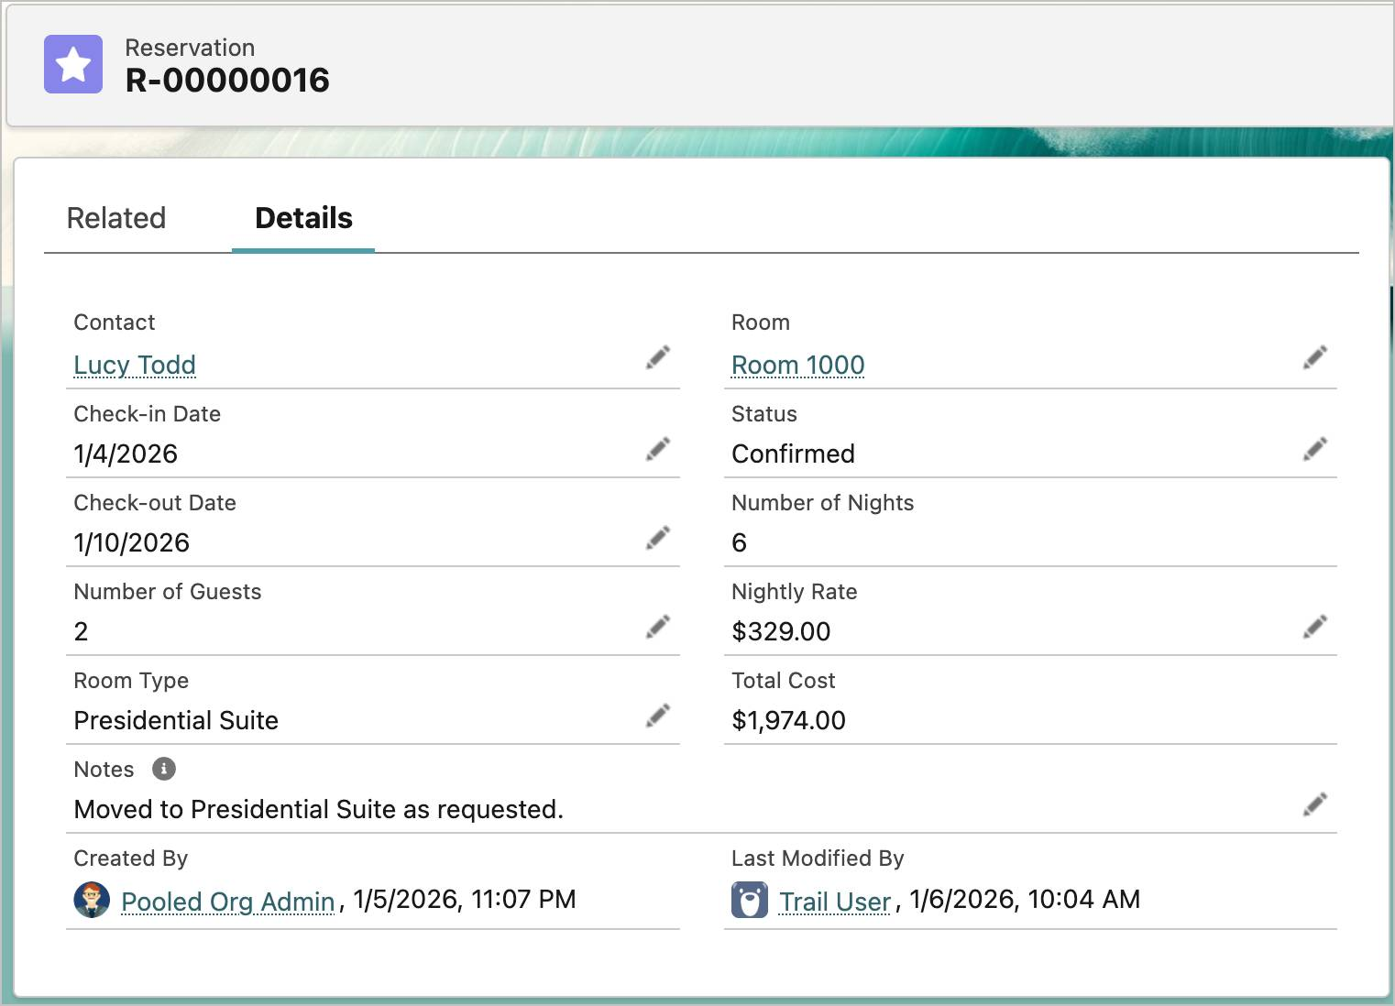
Generate a Confirmation Email
Now that you’ve successfully placed Lucy Todd in the Presidential Suite, it’s time to send her a confirmation email reflecting this change. You ask the agent to generate an email that you can send to Ms. Todd.
- Click  if the Employee Agent panel is not still open, and make sure the Guest Agent is still selected.
- In the Agentforce panel, copy and paste: Please generate an email letting Lucy know that her reservation has been upgraded to the Presidential Suite. Include the dates of her reservation in the email.Copy
- The agent generates the email. (It might take a minute for the email to populate in this step and in Step 5.)
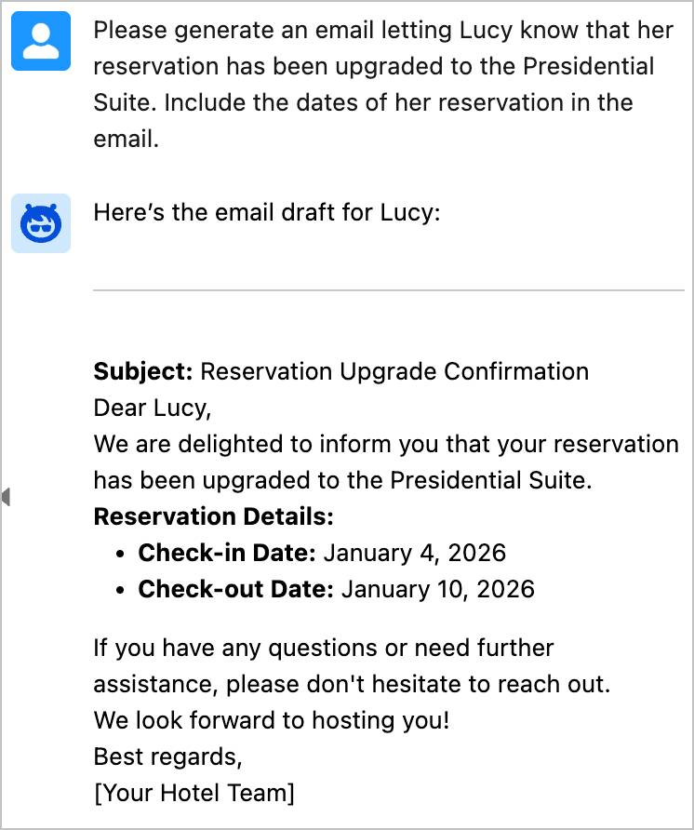
- You review the email, then click Send Email.
- The email opens in an email template that you can edit if you’d like. Click Send.

The email will be sent to the email address you provided when you signed up for the org.
Wrap Up
Ms. Todd is relieved to switch to a different room, and follows a staff member who has arrived to help her pack and move her luggage to her new suite. You apologize for the inconvenience and say goodbye. Phew, one fire drill contained! Click Check Challenge to Earn 500 points.
Now it’s time to set out and see what else is happening around the resort.
Hands-on Challenge
+500 points
Get Ready
You’ll be completing this unit in your own hands-on org. Click Launch to get started, or click the name of your org to choose a different one.
Your Challenge
It’s time for you to check your work. Please make sure you have followed all the steps above and click Check Challenge to Earn 500 Points to move on to the next unit.

Solve the Case of the Missing Diaper Bag
Learning Objectives
After completing this unit, you’ll be able to use an agent to:
- Create a case to find the missing diaper bag.
- Reassign a case to the proper team.
The Case of the Missing Diaper Bag
By early afternoon, the guests have relaxed into the day, and you see them splashing in the waves and snoozing in the sand. You make your rounds to introduce yourself to the staff at the various stations around the resort.
At the pool, the attendant enthusiastically shows you around and tells you he’s already used the new employee agents twice! Once to create a case to have maintenance retrieve a guest’s sunglasses from the bottom of the pool, and then again to assign a case to housekeeping to restock the towels.

As you walk down the beach, you meet the Beach Bootcamp Challenge experience coach who is raking the sand after a workout. She tells you about the bootcamp and some of the guests who come to compete against each other. She remarked about how the employee Guest Agent made it so seamless to instantly book drop-in guests into sessions. Previously, she had to send them back to the front desk to register for a session before they could join.
Just then, a woman holding a toddler races up to you, out of breath, and tells you that she’s missing her diaper bag. She said she left it in the beach cabana while she went for a swim and her partner was busy building sandcastles with the baby. They left the cabana to return to their room, neither noticing the diaper bag had been left behind. When they went back to look for it, a new family occupying the cabana said they hadn’t seen their bag. “Trust me, we need that diaper bag, asap!” she pleaded, holding her nose. She holds up a picture of her family and zooms in on the bag at their feet. “It looks like this,” she says.

“Well, this is definitely urgent,” you agree. “I’ll make sure the staff looks for your diaper bag right away.” “In the meantime,” you say, pointing just behind you, “the front desk has a stash of all sizes of diapers and supplies, and we can be sure you have what you need until we locate your bag.” The woman thanks him and heads over to the desk.
You remember seeing a housekeeping team cleaning beach cabanas between guests. You know you can use the new Customer Service employee agent to create a high-status case for the housekeeping staff to find the diaper bag.
Create a Case to Find the Missing Diaper Bag
- In the Coral Cloud Resorts app, click  to expand the Employee Agent panel if it’s not already visible.
- Click the arrow next to Guest Agent to expand the Select Agent menu. Select the Customer Service Agent from the menu, then click Select. Make sure the correct agent is selected.
- In the Agentforce panel, copy and paste: Create a case to find the lost blue and white striped diaper bag.Copy
- The agent responds to tell you the case was successfully created.
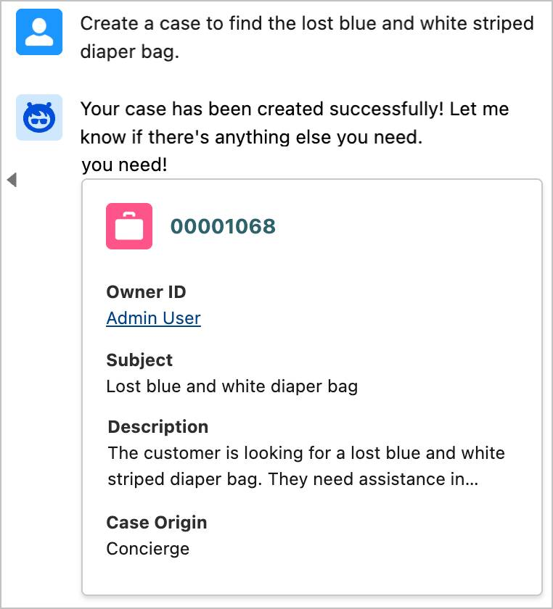
Assign the Case to Housekeeping
Assignment Rules are not set up in this org, so the Case Owner is currently set to you. You need to reassign the case to the Housekeeping team.
- In the agent response, click the case number, 00001068, to open the Case Feed. 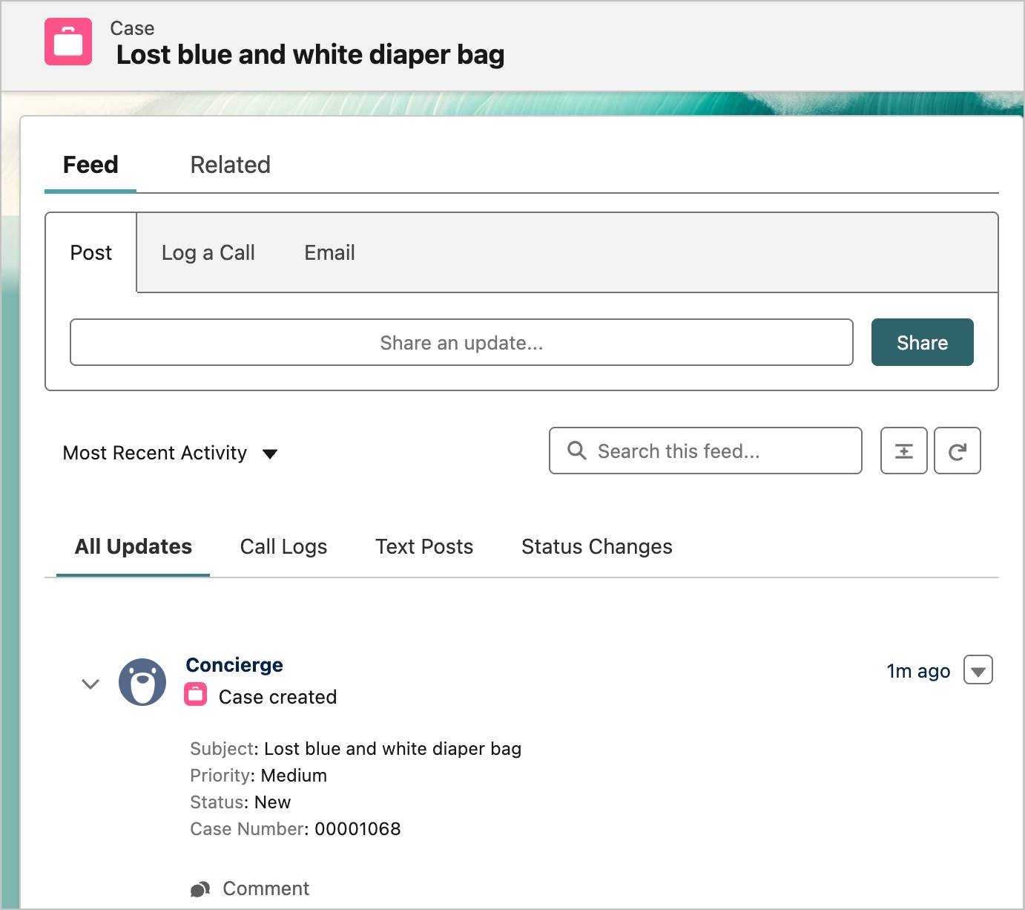
- In the agent conversation window, copy and paste: Reassign the case to Housekeeping.Copy

In some orgs where the language has been changed from English to another language, the User “Housekeeping” no longer exists and the agent is unable to reassign the case. This step is not being checked so please continue with this unit and you will be able to pass the Hands-on Challenge without reassigning the case. We’re working on fixing this issue.
- The agent responds to tell you that the case has been successfully reassigned to Housekeeping.
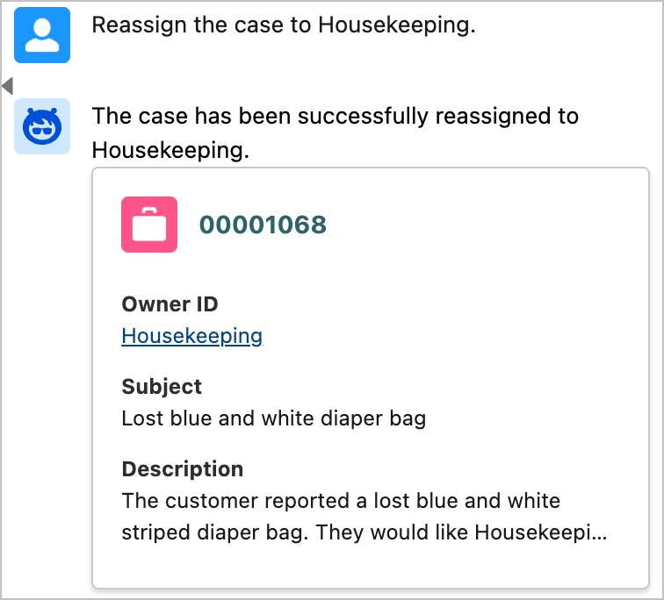
- Since this needs immediate attention, let's escalate the case so it gets the response it needs. In the agent conversation window, copy and paste: Change the Status to Escalated.Copy
- The agent tells you that the case status has been updated. If the agent is having trouble changing the status, try prompting it again.
- If the Case Owner or the Status field on the Case Feed does not automatically update, in the Agentforce panel, click the case number again to refresh the Case object and view the update. 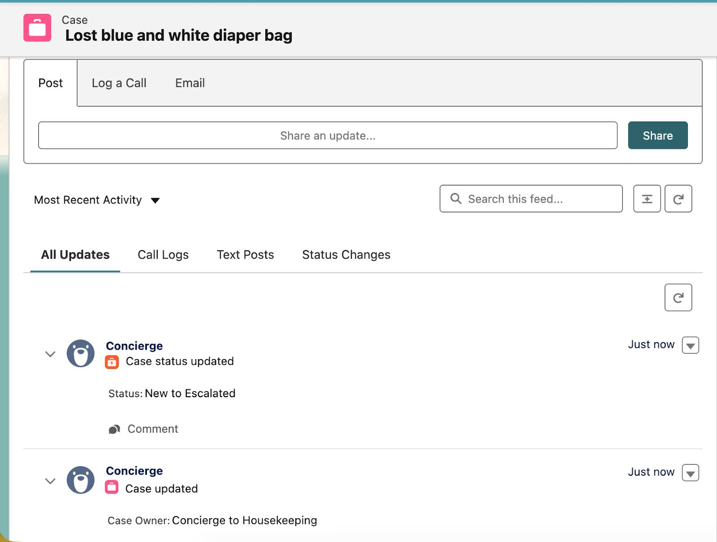
Wrap Up
You’re confident that someone on the Housekeeping staff will turn in the diaper bag and that the case will be resolved quickly. Check the following challenge so you can continue helping guests.

Navigate Guest Experience Bookings
Learning Objectives
After completing this unit, you’ll be able to use an agent to:
- Locate a guest’s Experience bookings.
- Cancel an Experience booking.
- Book a new Experience session.
Time to Unwind
After dinner, you finally get to relax around a firepit with some of your new coworkers to watch a brilliant sunset, enjoy a mocktail, and tell stories about the day. You recalled how Ms. Todd thanked you and said she was very happy with her upgraded room. The diaper bag was found. It had been en route to the Lost and Found when the case was created and was quickly returned to the family who lost it. Your new friends also shared how the new employee agents made them more productive with their day-to-day tasks, which gave them the ability to pay more attention to the guests.
The activity around the resort has quieted to evening murmurs, windchimes, and clicking heels on the tile floors as guests make their way to the dessert bar and to the patios for music, movies, and dancing.
.
Just as you swirl your paper umbrella toothpick around the bottom of your glass, Miko Mistumi, a guest in Room 324 approaches the table and holds out his phone to show you his reservation calendar. He explains that an experience that his wife booked, the Coral Bay Cruise, will make their eldest daughter really seasick and so they need to do something a little more landlocked instead. “She just adores the ocean and fish,” he explains. “So I’d like for her to be able to do more than just play on the beach. Is there an activity that you’d recommend where we can still enjoy the ocean together?”

“Let me take a look,” you tell him. “We certainly wouldn’t want your daughter to get seasick, or for any of you to feel like you’re missing out. Let’s find another fun experience for you and your family to go to tomorrow afternoon.”
Cancel Miko’s Coral Bay Cruise Experience Booking
You and Mr. Mistumi walk over to a nearby Concierge station to look at other activities his family might be interested in. You show him several other ocean-related experiences he can choose from and hand him a few brochures to look at while you cancel his Coral Bay Cruise booking.
- In the Coral Cloud Resorts app, click .
- Click the arrow next to the Customer Service Agent to expand the Select Agent menu. Select the General Agent from the menu, then click Select. Make sure the correct agent is selected.
- In the Agentforce panel, copy and paste: Show me the experience bookings for Miko Mistumi.Copy
- The agent shows you three experiences that Miko Mistumi has booked for his family during their stay. Note: Your bookings may appear in a different order.
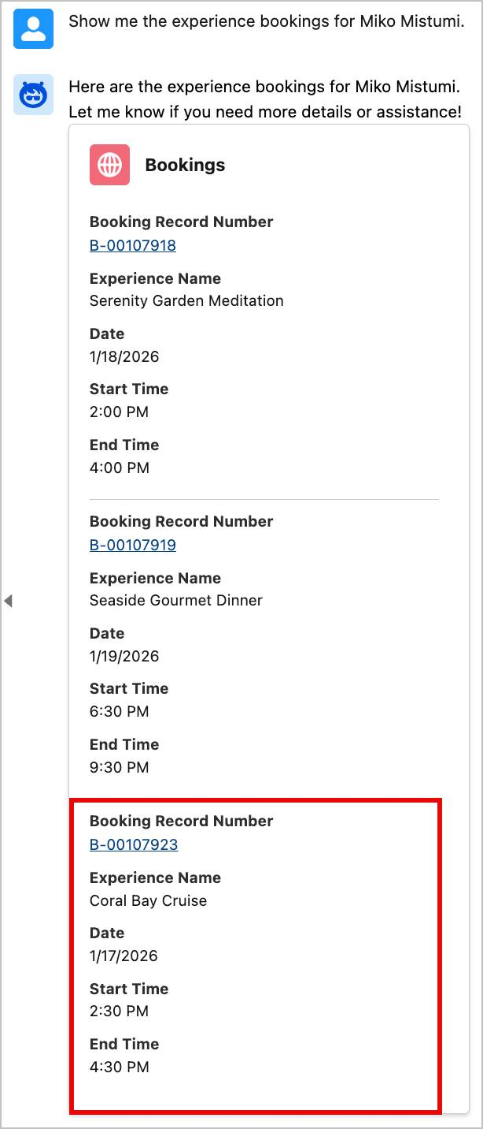
- Click the Booking Record Number, B-00107923, for the 2:30 PM session of the Coral Bay Cruise. The Booking Details page opens on the left.
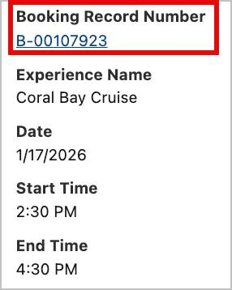
- Copy and paste: Please cancel the booking tied to this session.Copy
- The agent responds to tell you that the booking has been successfully canceled. The Status field in the Agentforce panel and in Miko’s Booking Details updates to say Canceled, and the Is Canceled checkbox is checked.
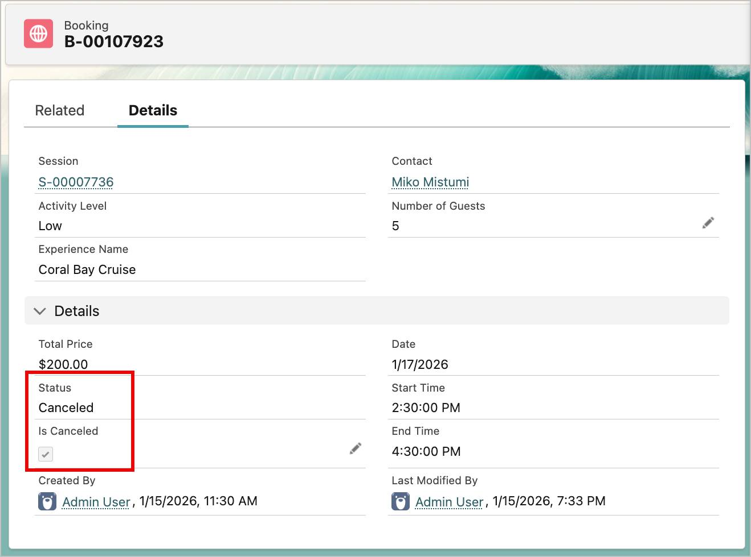
Book a New Session for Miko’s Family
Now, you need to rebook Miko Mistumi’s family for something fun tomorrow afternoon. Miko holds up the brochure for the Magical Aquarium Tunnel Tour and tells you that his family would love that activity.
- In the Agentforce panel, copy and paste: What is the next available Magical Aquarium Tunnel Tour session for 5 people?Copy
- The agent responds and shows you a session that is available at the same time as the session you just cancelled, and asks whether you’d like to book it.
- Copy and paste: Yes, book it for Miko Mistumi’s family.Copy
- The agent tells you that the booking has been successfully created.
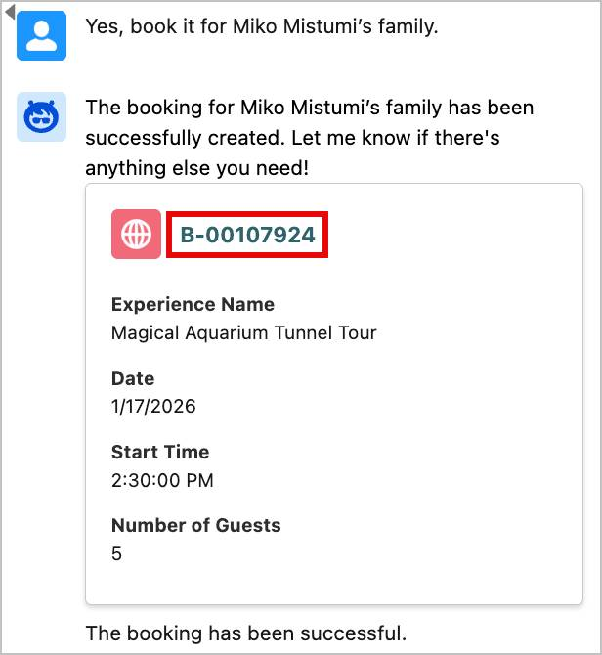
- In the Agentforce panel, click the new booking number, B-00107924, to view Miko’s new Booking Details for the Magical Aquarium Tunnel Tour.
Wrap Up
With Miko’s family happy with their new schedule, you head back to the firepit and rejoin your new friends. You had a wonderful first day, and the employee agents made it so easy for you to help guests. It’s as if you’ve been there for years! Tomorrow, you’ll explore the rest of the resort and become more acquainted with the staff.
Congratulations!
You just learned how using employee agents helps you accomplish routine tasks so you can spend more time focusing on the work that really matters. Before you go, don’t forget to check the challenge to earn this badge.

Hands-on Challenge

Get Ready
You’ll be completing this unit in your own hands-on org. Click Launch to get started, or click the name of your org to choose a different one.
Your Challenge
It’s time for you to check your work. Please make sure you have followed all the steps above and click Check Challenge to Earn 500 Points and complete this badge.
Let's Get Hands-On
To get hands-on with Salesforce you'll need a Trailhead Playground. You'll use this free Salesforce org to complete this and other hands-on badges.

